DELHI TECHNOLOGICAL UNIVERSITY

Python Programming
MC103


B. Tech. Mathematics and Computing

Submitted By: Submitted To:

Experiment No. - 1

WAP that creates variables of numeric data types and perform arithmetic operations on them in Python.

Code: -
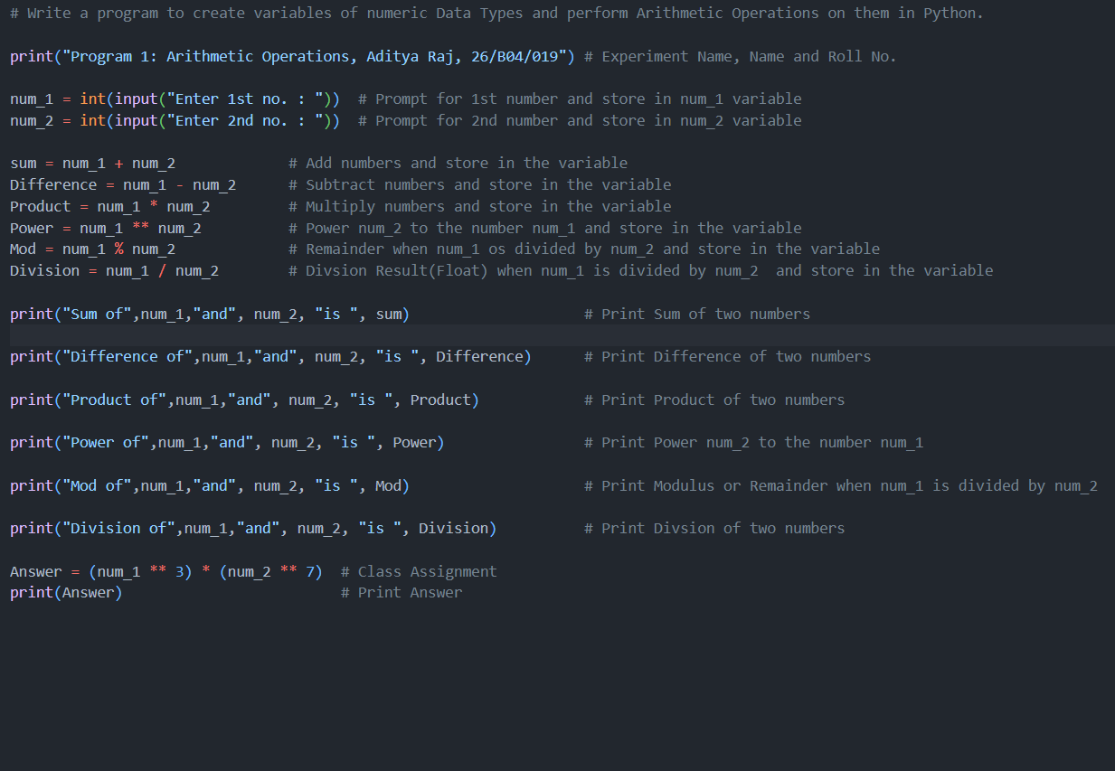

Output: -
